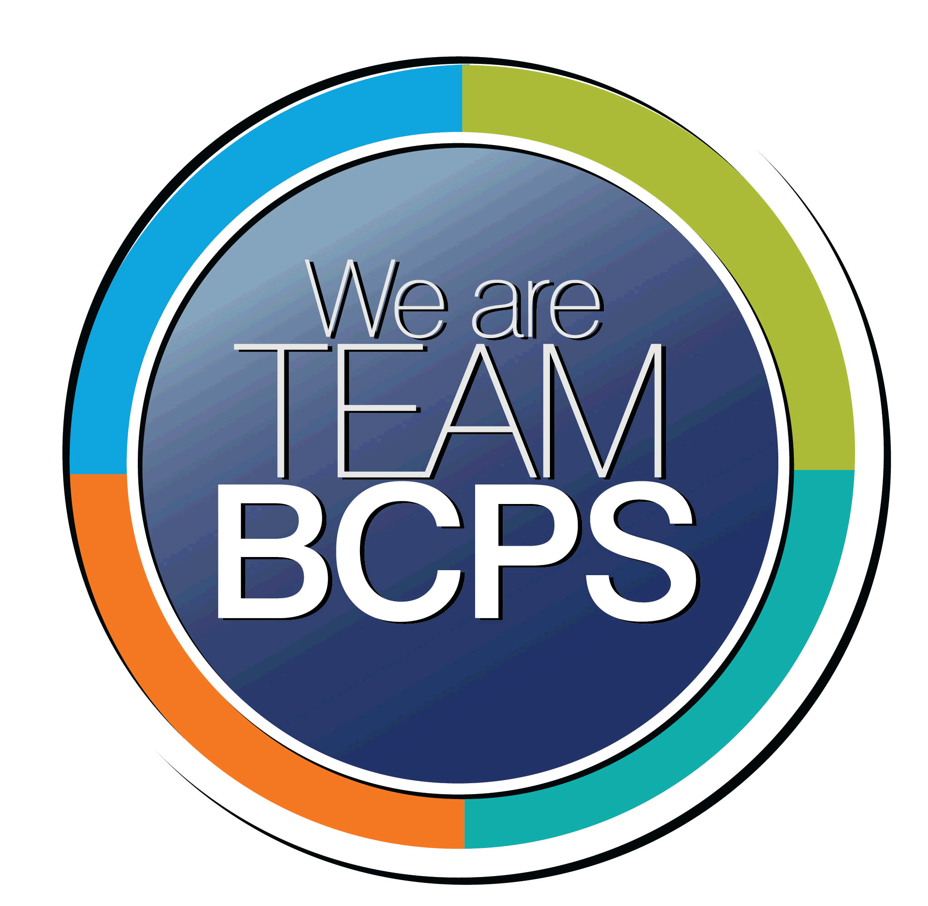 **Schoolwide Positive Behavior Plan** 

**Baltimore County Public Schools**

**Date Completed: 8/10/2022 School Year 2022-2023**

**School: Fort Garrison Elementary**

|  |
| --- |
| **Section 1: Initial Steps** |
|  |
| **School Climate Team** |
| *Identify members of a School Climate Team (consider a representative selection of members). The team meets initially to examine equity concerns and data and to develop the Schoolwide Positive Behavior Plan. The team should then meet monthly (minimum quarterly) to assess the effectiveness of the SWPBP on an ongoing basis.* |
| Hope Baier, Principal  Sara Solter, Assistant Principal  Shelly Borucki, School Counselor  Stacy Siegel, Reading Specialist  Jodi Cohen, Kindergarten Teacher  Lisa Levine, 5th grade |
| **Equity Lens** |
| *Through an equity lens, identify what the data indicate about the social-emotional needs of students and the support provided by staff members relative to disproportionality between student groups, especially for African Americans or students receiving special education. Also consider the school’s population with regard to ELL, Latinx, and/or other student groups. (Information may be from School Data Story)* |
| Student Population: For the 2022-2023 school year, Fort Garrison’s student enrollment is 292, with 121 female, and 171 male. There are 219 white students and 73 students of color.  With regard to special services, there are 3 English learners, and 79 students receiving special education services, either in the form of an IEP or 504 plan. FGES has several regional programs; OGE 3’s and 4’s, CLS Kindergarten, Primary and Intermediate. There are 25 students in these programs, 3 students are white, and 22 students are of color.  Results from Fort Garrison’s Data Story for the 2021-2022 school year revealed the following: The overall enrollment count at Fort Garrison Elem has increased since 2020-2021. During the same period, the number of Black/African American, Hispanic/Latino, and Two or More Races students and students who receive Special Education services has increased while the number of White students and students who receive Free and Reduced Meals has decreased. |
| **Data Analysis** |
| *Summarize what the data tell about the school climate. (Information from School Data Story)* |
| Analysis from the School Data Story revealed that the dominant culture of Fort Garrison is white students and white teachers.  The percentage of black students and black staff is relatively small. We wonder the impact of the white dominant culture on our Black students (approximately 1 in 5 students are Black with the majority of the Black students enrolled in a regional program) with regard to feeling a sense of Belonging. Results of the Stakeholder Survey indicated that Black students rated a sense of belonging at 73.4% combined for favorable (66.7%) and very favorable (6.7%). Systemwide, black students rated a sense of belonging at 78% combined; 64.4% as favorable and 13.6% very favorable. Fort Garrison black students have a lower rating than BCPS total. When comparing all student groups from Fort Garrison to BCPS, Fort Garrison scored lower overall and in all student groups. The response rate for students at Fort Garrison was 89%.  11% of the student population did not complete the survey.  We must ensure that we have 100% participation in the future.   The percentage of Black students may be misinterpreted when reviewing data, specifically student achievement and Stakeholder Survey results. Out of the 73 students of color at Fort Garrison, 22 students are enrolled in a regional program and do not take the Stakeholder Survey. |
| **Climate Goals** |
| *Identify the school’s goals in improving the social-emotional climate of the building. (Information from School Progress Plan)* |
| The Instructional Leadership Team identifies creating an environment where all children are respected, feel welcome and have a sense of belonging, particularly our Black and Brown students as a schoolwide focus. The school will continue the work in creating an environment where all children are respected, feel welcome and have a sense of belonging, particularly our Black and Brown students.  Regular contact will continue during the first semester with students and families to address a sense of belonging and connection. |
| **Section 2: Developing and Teaching Expectations** |
|  |
| **Expectations Defined** |
| *Identify a School Code of Conduct with 3-5 positively stated school expectations. Develop a way to communicate the identified rules, based on the schoolwide expectations, for specific settings within the school building. Expectations should be clearly stated, communicated, taught, and frequently referenced.* |
| Fort Garrison foxes are Respectful, Responsible, Safe and Prepared. The code of conduct is recited each day during the morning announcements. Each classroom and other selected areas of the building have the Code of Conduct posted and it is referred to on a daily basis. Students are highlighted when they demonstrate the targeted skill. |
| **Classroom Plan for Teaching and Reinforcing Expectations, Routines, and Procedures** |
| *Teachers develop visuals to communicate culturally relevant classroom expectations, routines, and procedures based upon the schoolwide expectations. Educators explicitly teach expectations, routines, and procedures. The school staff recognize and reinforce expected and positive behavior. Teachers identify encouraging procedures and corrective procedures for their classrooms.* |
| **In the beginning of each school year teachers develop their set of classroom rules that align with the Code of Conduct as well as in all areas of school life (e.g. on the bus, at recess, field trips etc.). Conscious Discipline is taught and reinforced. All students receive the BCPS Student Handbook Talk. Positive behavior is reinforced and celebrated with Positive Office Referrals, Fox Paws, Schoolwide quarterly celebration assemblies, and utilizing 5th grade helpers with CLS students and primary grades.)** |
| **Family/Community Engagement** |
| *Identify how the Schoolwide Positive Behavior Plan, the schoolwide expectations, and/or interventions will be communicated and shared with families. Consider how to include family and student voice in the initial plan and in evaluating the plan throughout the year.* |
| At Back to School Night teachers will provide families with information relative to the Code of Conduct, School Behavior Plan, and Positive Office Referrals and other incentives (Fox Paws, positive phone calls, etc.). Information will also be shared with parents during PTA meetings. Morning meetings include student voice as the classroom reviews virtues and schoolwide policies and rules. |
| **Section 3: Developing Interventions and Supporting Students** |
|  |
| **Resource Mapping of MTSS** |
| *Identify the evidence-based practices and interventions offered at Tier 1, Tier 2, and Tier 3 to support all students. Consider what culturally responsive interventions the school requires to meet the specific needs of the students.* |
| Tier 1 Conscious Discipline, Fox Paws, Positive Office Referrals, Morning Meetings, Classroom Guidance Lessons  Tier 2 Small group counseling, coaching, and instruction, lunch bunches with preferred adults, planned breaks, peer mentoring, positive behavior charts, SST meetings, Student Support Team plans.  Tier 3 Crisis counseling, following the FBA and BIP, consultation with appropriate offices |
| **Social-Emotional Learning** |
| *Identify the specific evidence-based social-emotional learning skill development practices the school will implement during the school year. Consider the importance of trauma-informed care, mental health awareness, level of students’ coping skills, etc. Determine how the social-emotional learning and the SEL competencies will be integrated into the school’s programming. Consider the need for any training the staff members may require.* |
| Conscious Discipline, Safe Place (Calm Down Corner), Morning Greetings including teachers greeting students as they enter the building, Classroom Guidance Lessons, Morning Meetings, Teacher to student relationships to resolve conflicts. Zones of Regulation. Training is available for staff through BCPS professional learning and through consultation with the school counselor and social emotional learning teacher, When providing support, staff will consider a trauma informed approach when appropriate (e.g. consider cultural responsiveness, utilize the PPW). |
| **Character Education** |
| *Determine how specific evidence-based character education learning will be infused into the school’s programming to promote positive behavior and ethical decision-making. Character education will be culturally responsive and co-created with diverse stakeholders. Consider the need for any training the staff members may require.* |
| Teachers will nurture emerging talents and offer opportunities for reflection and discussion in various learning areas such as ELA, writing and health courses. Classroom guidance lessons will reinforce positive behavior and ethical decision-making. Virtues of the month will be reinforced and highlighted in Positive Office Referrals. |
| **Professional Development for Staff** |
| *Identify the professional development that will be offered to staff members throughout the year in order to support their knowledge, skill development, and implementation of the interventions selected, the character education learning, and social-emotional learning practices. Specify the schedule for professional development and how to obtain teacher feedback during the year to address their concerns and areas in which they want/need more information. (Information from School Progress Plan.)* |
| All new staff will be briefed on the plan during pre-service week and updates will be shared during faculty meetings. Professional learning will be facilitated by the School Counselor, School Psychologist and Social Emotional Learning teacher regarding best practices and procedures for handling negative behavior. FBA and BIP information will be shared by case managers and the IEP chair regarding identified students in need of accommodations. Staff will be encouraged to take advantage of systemwide opportunities for restorative practices and behavior management. At grade level and faculty meetings staff will have the opportunity to share feedback and strategies for behavior. |
| **Section 4: Supporting and Responding to Student Behavior** |
|  |
| **Recognitions/Incentives** |
| *Identify a variety of positive consequences, acknowledgements, recognitions, and/or incentives that are linked to the behavioral expectations and rules. Develop a system for implementing the positive acknowledgements consistently in school settings. Consider how to monitor who is being recognized and who is not being recognized and whether explicit or implicit biases may be occurring.* |
| The follow recognitions and incentives will be implemented this school year. The “wall of fame” displayed in the main hallway recognizes students who have received Positive Office Referrals. Students who earn 6 fox paws during the day speak during the afternoon announcements and receive a prize. |
| **Hierarchy for Behavioral Referrals and Consequences** |
| *Identify the behaviors that are teacher-managed, behaviors referred to resource staff, and behaviors referred to administration. Refer to the BCPS Student Handbook for teacher and administrator-led interventions. Consider how unsafe behaviors will be addressed.* |
| See attached |
| **Response for Intensive Behaviors** |
| *Identify a hierarchy of responses to intensive behaviors (i.e., emergency/crisis management/threat assessment/unsafe behaviors) including interventions and supports. Indicate which school staff members will respond as well as procedures and training as needed.* |
| Historically, students at Fort Garrison with intensive behaviors receive special education services in the form of an IEP or 504 plan with accompanying FBA/BIP if appropriate. CPI trained staff and other support personnel including the School Counselor and School Psychologist would intervene as needed. The hierarchy of responses are outlined in the individual student’s BIP. Examples may include creating a safe space, removal of peers or removal of student, using first/then language, breaks, and offering choices) |
| **Monitoring the Schoolwide Positive Behavior Plan/Data Analysis** |
| *Identify the data that will be collected and reviewed by the School Climate Team in order to identify behavior trends, patterns, action steps, and interventions using a problem-solving strategy. Consider having a uniform referral form for staff to complete to document referrals to administration. Consider how teachers should document classroom-managed concerns/behaviors/difficulties. (Information from School Progress Plan.)* |
| Data will be collected in the following ways; office referrals (positive and traditional), Stakeholder Survey results, wall of fame, teacher and student feedback. A uniform office referral form is in place. |
| **Section 5: Miscellaneous Content/Components** |
| n/a |